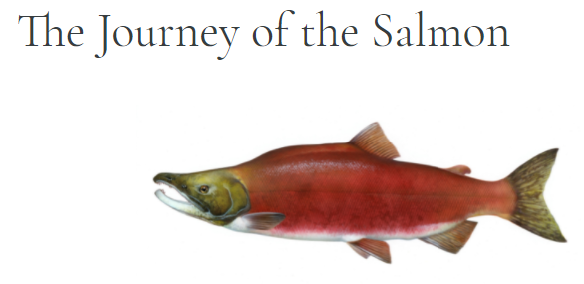 Salmon are born in small freshwater rivers but move to the big ocean when they mature. That’s super cool because salmon is one of only a few fish in the whole world that can live in both fresh and saltwater! But between September and November every year, a salmon's instinct to spawn (that means lay eggs). This instinct causes them to swim all the back to the river they were born known as a “spawning ground" to lay their eggs. Salmon can live for up to seven years so it’s quite remarkable that after all that time, they can find the exact place they were born. Salmon can detect magnetic fields which means they always know the right way to go. It’s kind of like a GPS built right into their fishy brains. Also, salmon have an amazing sense of smell, Researchers believe that salmon can sniff out chemical clues in the water which can trigger their memory that will lead them to their spawning ground.

Journey:

Salmon face a lot of obstacles during the salmon run. For starters, they must swim against the river's current the whole way. Sometimes up to 4,000 kilometres! Salmon also have leap over waterfalls, rapids, and dams. Believe it or not, these amazing fish can jump two metres high (and some even higher than that)! But skilled predators like bears and eagles wait around every river bend to catch salmon when they jump out of the water. The salmon run is hard and can change the appearance of the fish. Some species of salmon change colour. Some males even develop humps on their backs and grow hooked jaws and fangs to defend themselves! Very few salmon survive. Most Pacific Salmon die after depositing their eggs — these fish become an important source of food and nutrients for the local ecosystem. And research shows only 5 to 10% of Atlantic Salmon will return to the ocean and make the journey again next year. But it’s an important part of our ecosystem and the salmon run ensures future generations of these amazing fish!

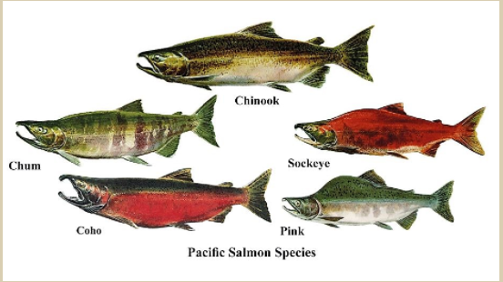

Life cycle:

Salmon go through a variety of stages during their life cycle. The main stages are egg, alevin, fry, fingerling, smolt, ocean adult, and spawning adult.

The cycle begins in freshwater, when a redd, or a female's nest of eggs, is fertilized. These eggs remain in the gravel throughout the winter, and the embryos develop. In the spring, the eggs hatch and alevins emerge.

Salmon lay their eggs in many streams and rivers. Depending on the species, a female salmon will lay anywhere from 1,500 to 7,000 eggs in a nest or redd she has created by making a shallow depression in the stream bottom. The male fertilizes the eggs and then both fish push gravel over them to protect them.

As salmon grow in the ocean environment, they accumulate marine nutrients, storing them in their bodies. They then transport those nutrients back to their stream of origin when it is their time to spawn, die and decay. Salmon release their eggs and milt back into the freshwater to re-seed the cycle.

How long does it take for salmon to migrate?

Young Atlantic salmon spend two to three years in their home river before going on a one to three-year journey in the North Atlantic where they grow into an adult. They travel over 6,000 miles before coming back home to spawn.

**Salmon Life Cycle Daigram:**

